User’s manual Controller Version 3.0
This document is a manual Controller board for version 3.0. It covers how to configure a static IP Address for device and the process had received a card.
- Configure a static IP Address.
In the Chrome, Firefox enter IP address: 192.168.1.50 (default)
A login page will appear as shown in Figure 1. You must enter Username: admin and Password: admin to login (Bother is default). You can change it if you login successfully.
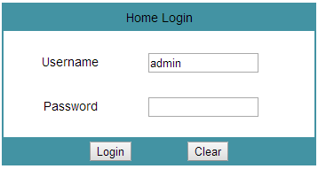
Figure 1 A login page
After you login successfully, a configuration page will appear as shown in Figure 2. In the configuration page, you can configure static IP address your device.
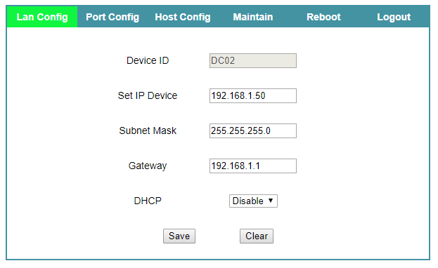
Figure 2 Lan configuration page
Click Save button to save configuration, After saved configuration, Click Reboot button to reboot device (after reboot the device, Configuration is take effect).
Figure 3 Port configuration pageshown the configure page for the port. This is the page, we can configured type and active status of the port. Where, port 0 and port 1 is fixed. It is not changed type of port, but we can changed active status of the port.
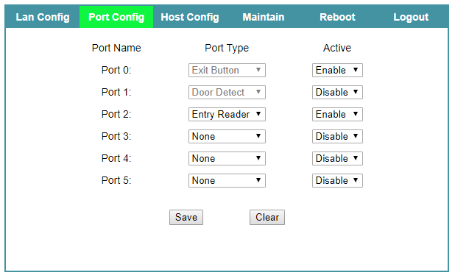
Figure 3 Port configuration page
Figure 4 Host Configuration page shown the configure page for the host. Here, we can configure the server address, server name, user name and password to access the server account.
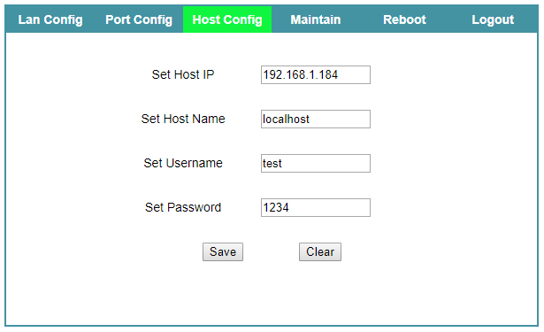
Figure 4 Host Configuration page
Figure 5 Maintain Configuration page shown the configure page for the username and password to login the page.
You can enter new username and password, if you want.
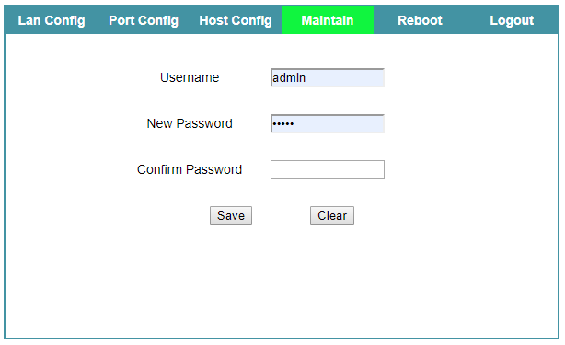
Figure 5 Maintain Configuration page

